A Quick Start Guide for ePals Students Using ePals SchoolMail

What is ePals?

ePals SchoolM@il™ is a safe Internet-based email solution and a collaborative tool designed for the education environment. With ePals tools you can:

• Communicate in a safe and secure environment with your teachers, classmates and students around the world.

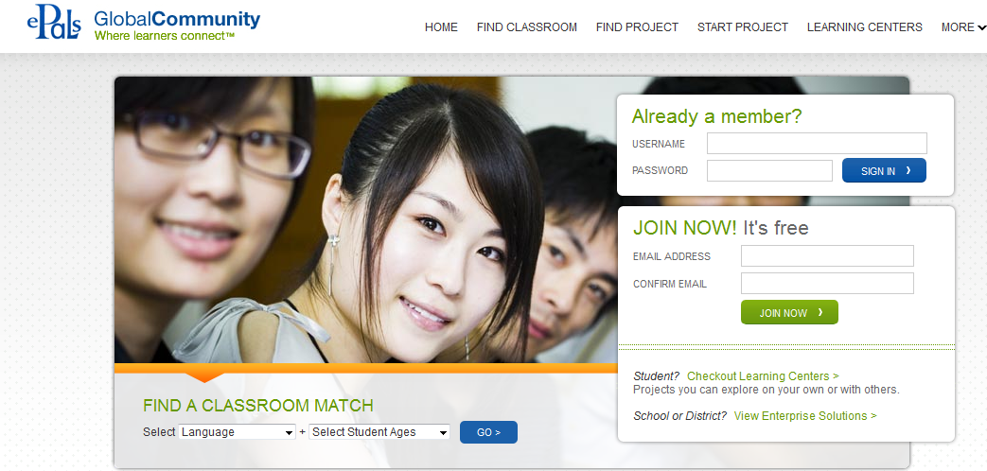

Accessing ePals

To access ePals go to www.epals.com.

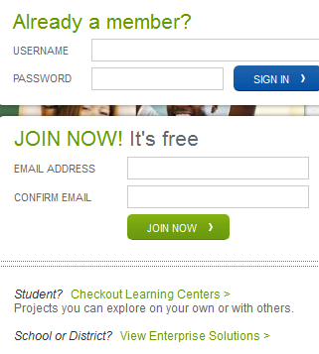

Using the username and password that is provided to you by your teacher or school,
log into your ePals SchoolM@il account.

ePals SchoolMail HomePage

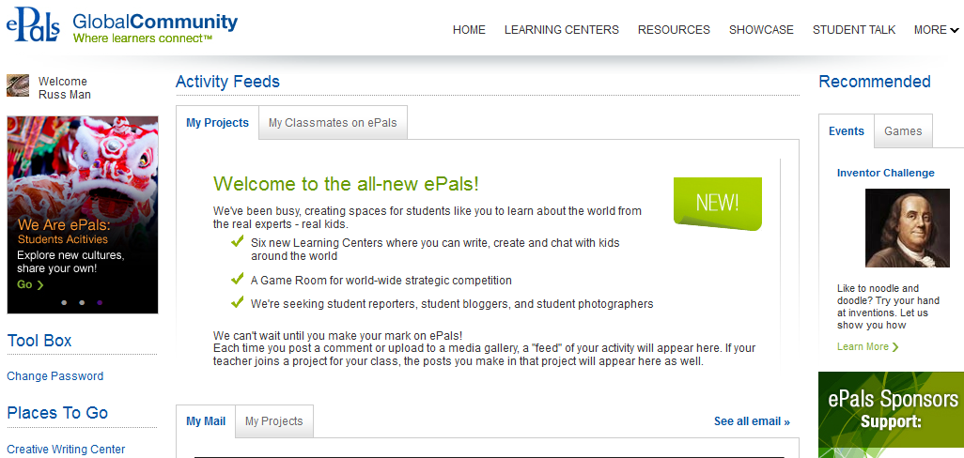

Sending and Receiving Emails

To access your own email, click on “InBox.”

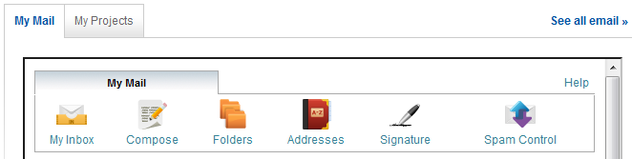

Keep in mind that your school may have placed restrictions on who you can email
through your ePals account. You may want to check with your teacher for any specific details. Also remember that your teacher is monitoring the email messages that you are both sending and receiving.
If you wish to view your email in full screen you can choose the See all email link on the right hand side of your mail section.

From your inbox you can view your received messages. Use your mouse to point to the message you want to read and then click on the subject of the email.

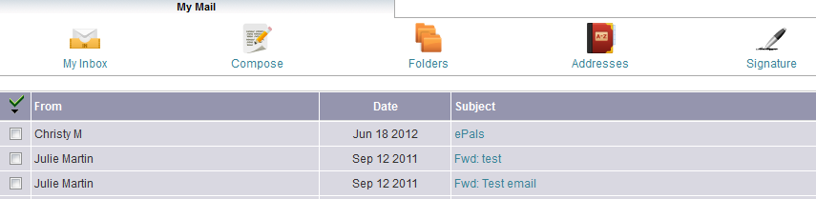

This will open your message.

Click “Reply” to reply to the person that sent you the message
Click “Reply All” to reply to everyone that received the message as well as the person that sent you the message

Click “Forward” to send this message to someone else

Click “Delete” to delete this message and send to your trash folder

Click “This is Spam” to flag this message as spam which will move the message to

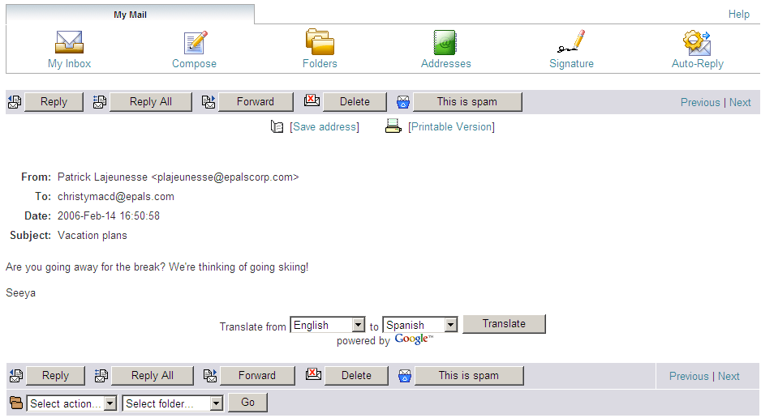

Anytime you want to return to your ePals homepage, click the “My Home” icon in the top right of the screen.

Compose an Email
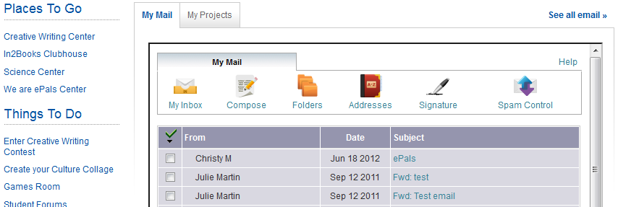

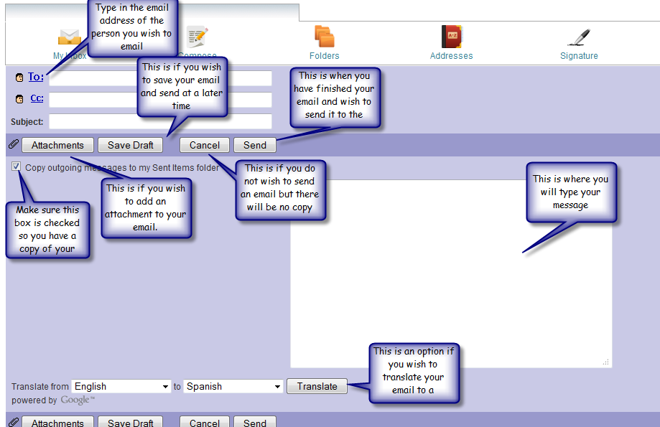

Using the Language Translation Tool

ePals offers a simple way to translate emails and text in a variety of different languages. Please note that automatic translation software is effective for conveying the "gist" of your message, and will not be a perfect translation.

• Helps eliminate language barriers within the ePals global community
• Can be applied to incoming and outgoing mail

To Translate Emails
To translate an email, simply type the e-mail and then choose

the desired language from the dropdown menus. Then click “Translate.”

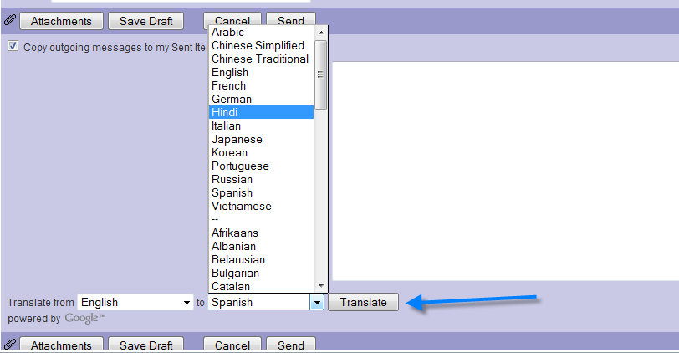

The same can be done when you receive an email you can open the email and choose to translate the body of the email from the language it was sent in to the language you wish to read it in.

Folders

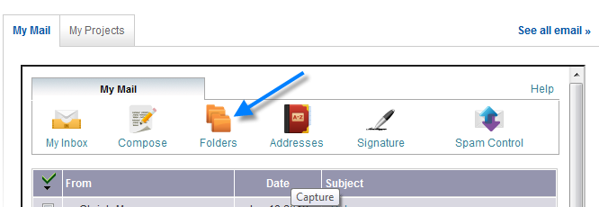

To view your folders click on the “Folders” Link

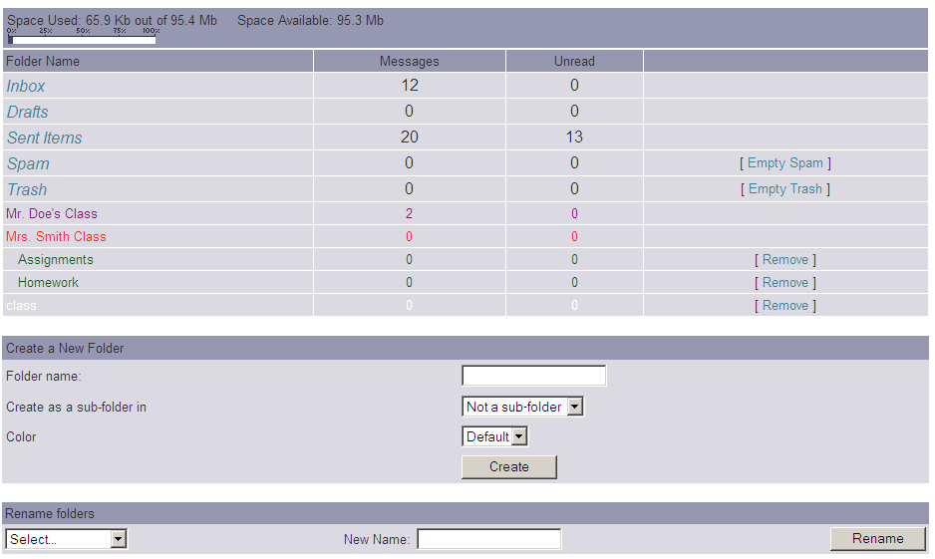

This link will take you to your folders. The following folders are created by the system and cannot be changed or deleted:

Inbox
Drafts
Sent Items
Spam
Trash

You also have the ability to create personal folders in the “Create a New Folder” area on this page.

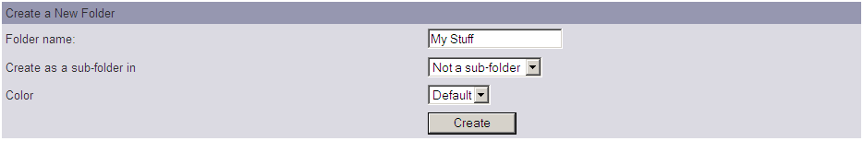

Choose a folder name. In this example we are using “My Stuff”.

Create as a sub-folder in means do you want this folder to be created under another folder already in your folders list. For example, you can choose to create a sub-folder under your inbox where you can store all of your messages that you receive from your teacher in one location. To create a folder in your main list of folders select the option “Not a sub-folder” to create a sub-folder click on the arrow beside the “Create a sub- folder in” option and select the folder where you want to put your new folder.

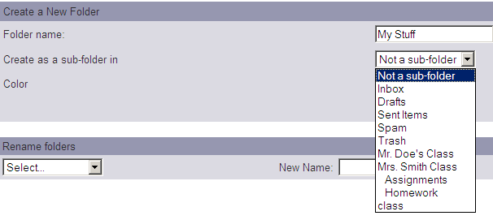

Next you can choose a different color for your new folder. The folder name will appear in the color you choose.

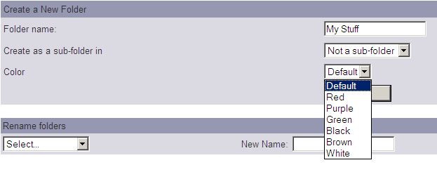

Finally, click “Create”
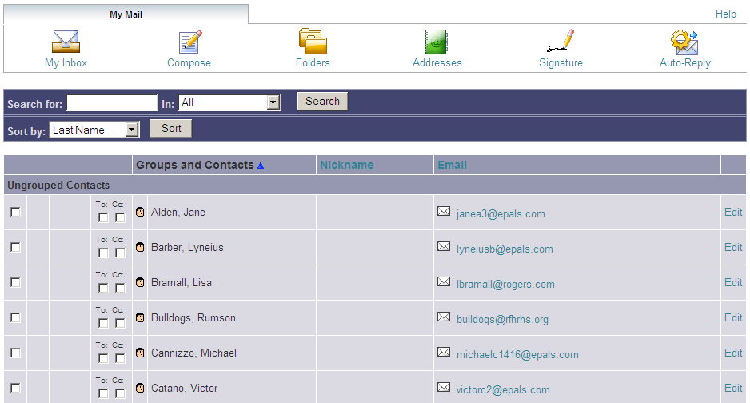

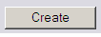

And your new folder will appear in your list of folders.

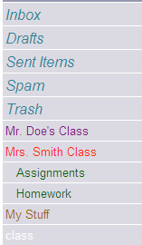

Addresses

The “Addresses” link will take you to your address book. This is where all of your contacts and email addresses will be stored. You can add a new contact to your address book when you are sending your friend an email for the first time.

Simply click the button beside “Add recipient(s) to my Address Book” and this new contact will appear on the page containing “Addresses”

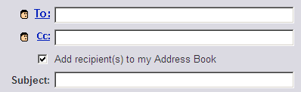

Signature

If you would like to create an ending or signature that you use at the bottom of every email, you can create one by clicking “Signature”.

Or create a new signature. Click on “New Signature”.

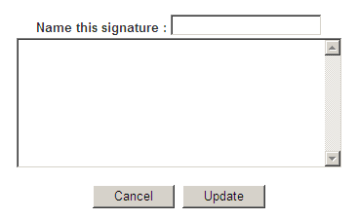

Name of this Signature: In this area give your signature a title for example
“Christy”
In the message area type your ending or signature. An example of a signature is: Have a nice day!
From, Christy

Once you are happy with your signature click the “Update” button.

If you wish to start over click the “Cancel” button.

After you are finished and you have clicked the “Update” button you will return to the first screen. Now your new signature will show up in this area.

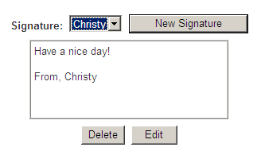

If you have created more than one signature use the drop down area to select the signature you wish to use.

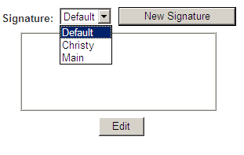

Stay Safe – Student Internet Tips

• Do show your parents, teachers and other trusted adults all the cool things you
like to do online and tell them about the friends you're making.
• Do be respectful when you're writing to or chatting with people on the Internet and treat them in the way you like to be treated.
• Do ask your parent or teacher before you sign up for anything on the Internet and do get permission before you download anything from the Internet.
• Do check with a teacher or parent before you send anybody pictures or other
files.
• Do let a parent, teacher or other trusted adult know if something unusual, upsetting or scary happens to you online.
• Don't respond to email, forum or chat messages that are mean, scary or make you feel uncomfortable.
• Never give out any personal information to anyone without the permission of a
parent, guardian or teacher.
o Don't tell people your last name.
o Don't give out your phone number or address.
o Don't tell people the name of your school without permission from a parent or teacher.
• Don't share your password with anybody other than a teacher or parent.
• Don't believe everything you read. Sometimes people on the Internet get their facts wrong or pretend to be someone or something they're not.
• Never arrange a face-to-face meeting without a parent, teacher or guardian
present.
• Always make sure you log out when you are done using ePals, to ensure that your personal information remains confidential and that no one else can use your account.

Best Practices for your ePals SchoolM@il Email

• Be a Smart Writer
o Make a Good Impression with your ePal
o Proofread (revise and edit) before sending
o Let your personality shine through your words
o Use powerful words
o Ask questions to encourage more conversation
• Follow Class Rules when Communicating
o Stay on task
o Use your words to show respect and compassion
• Use Appropriate Language
o No bullying—teasing
o No gossiping—talking about others
o No naughty words
o No “texting” language – email is more formal than texting

